Install RabbitMQ on Windows:

https://www.rabbitmq.com/docs/install-windows

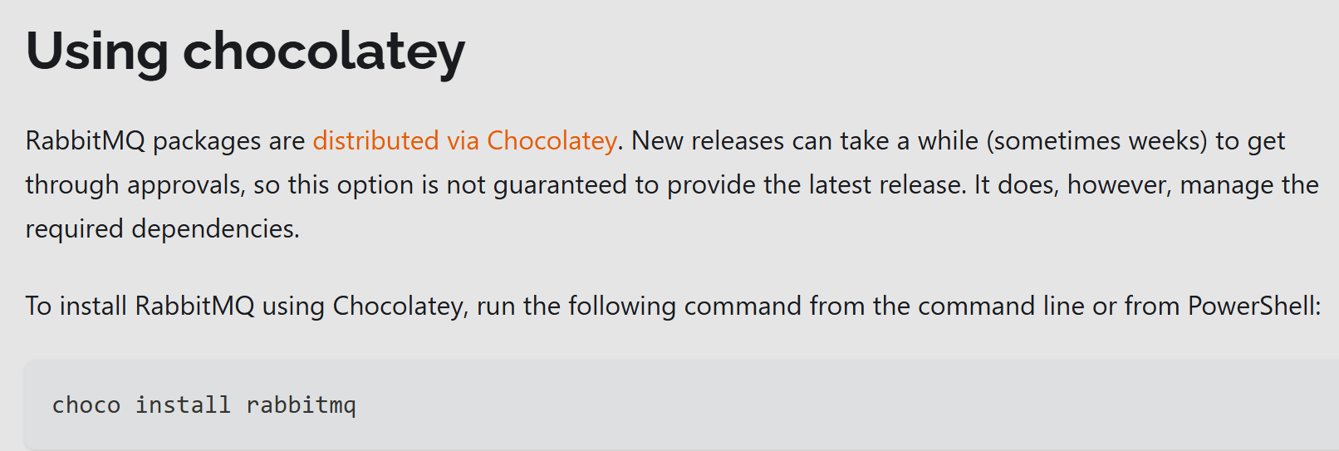

choco install rabbitmq

1. Add RabbitMQ to Your PATH

For Windows 10/11:
- Open the Start menu and search for "Environment Variables"
- Select "Edit the system environment variables"
- Click "Environment Variables" (bottom right)
- Under "System variables", find Path and click Edit
- Click New and add these paths (adjust if you installed elsewhere):
C:\Program Files\RabbitMQ Server\rabbitmq_server-4.0.7\sbin
(Replace 3.0.7 with your RabbitMQ version)
- Click OK on all windows to save
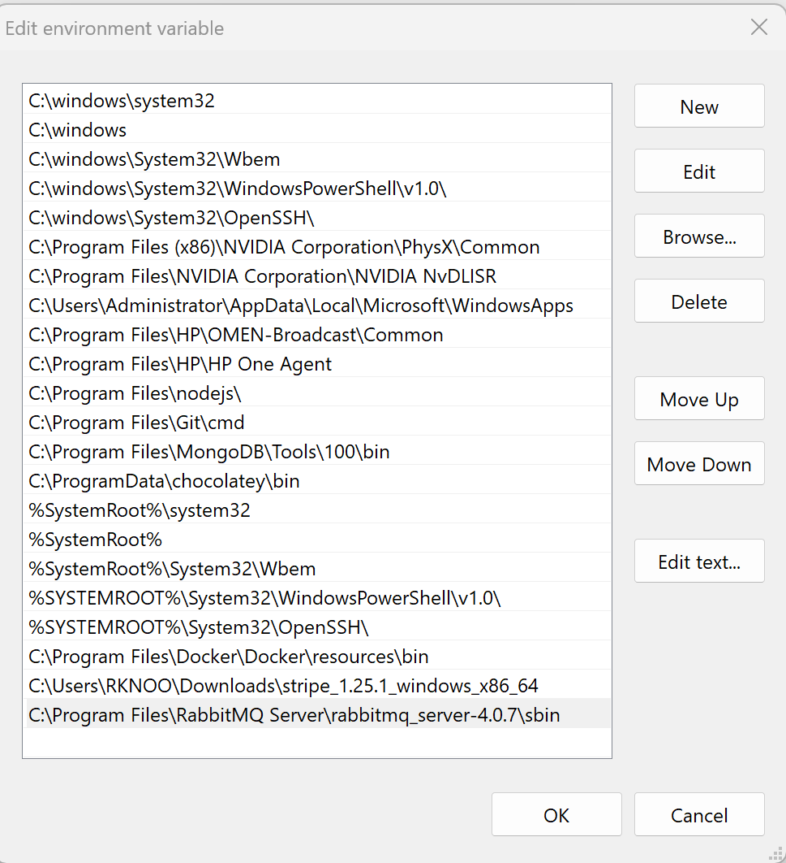

Verify Installation Path
If you're unsure where RabbitMQ installed:
- Check C:\Program Files\RabbitMQ Server\
- Look for a folder like rabbitmq_server-4.x.x

2. Open a New Command Prompt
Close and reopen PowerShell/CMD after changing PATH.

3. Now Run the Plugin Command
# List plugins (should work now)
rabbitmq-plugins list

# Enable delayed message plugin
rabbitmq-plugins enable rabbitmq_delayed_message_exchange

# Restart RabbitMQ (via Windows Services)
Restart-Service RabbitMQ

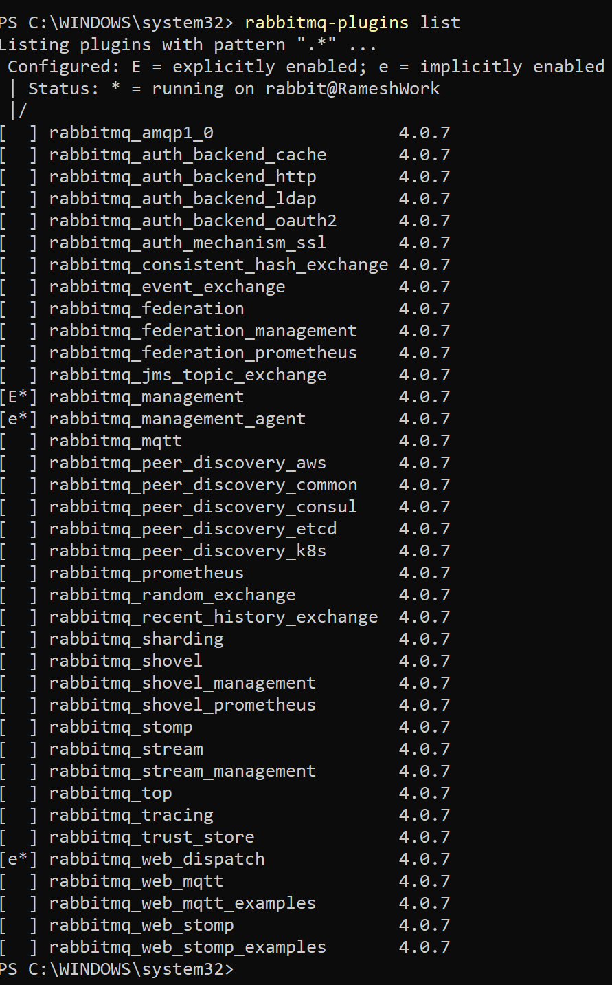

-------------------------------------------------------------------------------------
- Enabling rabbitmq_delayed_message_exchange plugin

Run this command to enable rabbitmq-delayed-message-exchange plugin.

rabbitmq-plugins enable rabbitmq_delayed_message_exchange

If the plugin enabled successfully, the output will be like:
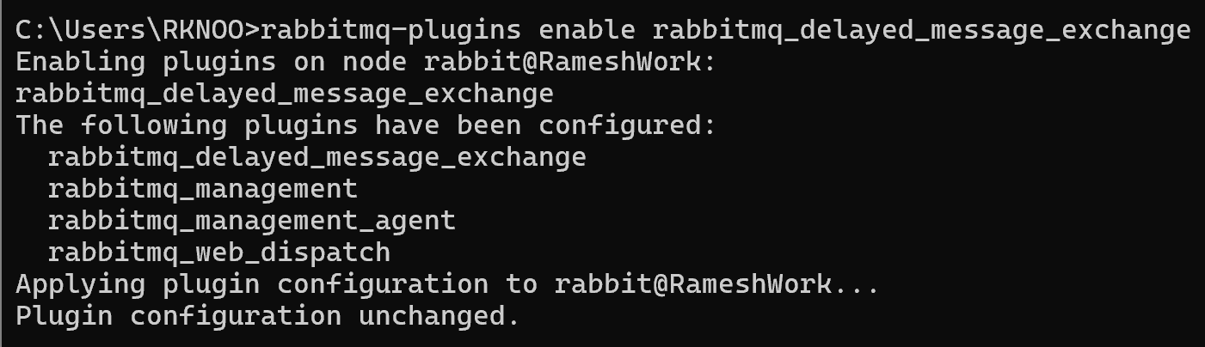

If the plugin is not found?
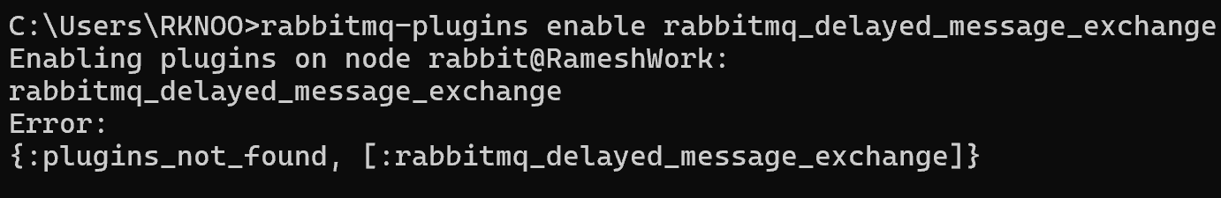

Then Do follow below steps:

1. Ensure You installed rabbitMq server on your machine.

2. Download rabbitmq-delayed-message-exchange-v4.0.7.ez file (that will found when you open below link) and Move it into C:\Program Files\RabbitMQ Server\rabbitmq_server-4.0.7\plugins.

https://github.com/rabbitmq/rabbitmq-delayed-message-exchange/releases

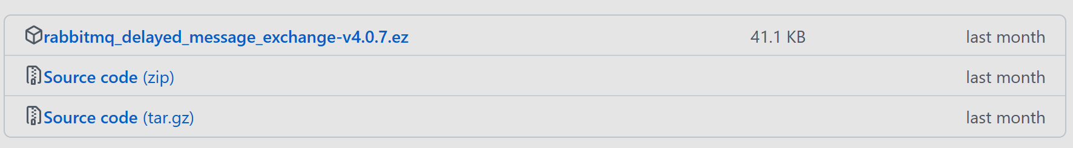
- Then run this command to enable it:
rabbitmq-plugins enable rabbitmq_delayed_message_exchange

-------------------------------------------------------------------------------------

